**Voice Recognition Model**

**Introduction :**

A voice recognition model provides a smarter way to communicate with vehicles, provides a user friendly experience. It makes use of Computer Vision and Machine Learning for development of algorithms.

**How to use:**

Its very simple and you need to perform the following steps:-

1. Via Laptop
2. Open the Software
3. Click on the “Mic” icon and start speaking
4. If your command are in *Table,* result will be displayed otherwise it will return “Sorry”
5. Reuse the application again

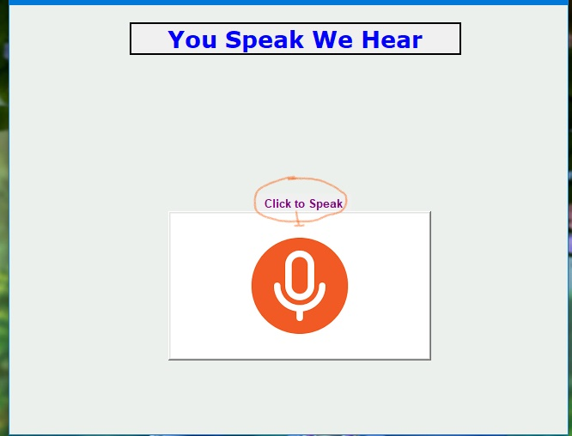

**B)** Via Mobile

1. Connect the module and the your mobile to the same network

2. Open *Google Assistant*.

3. Give your voice input

4. Check the LED

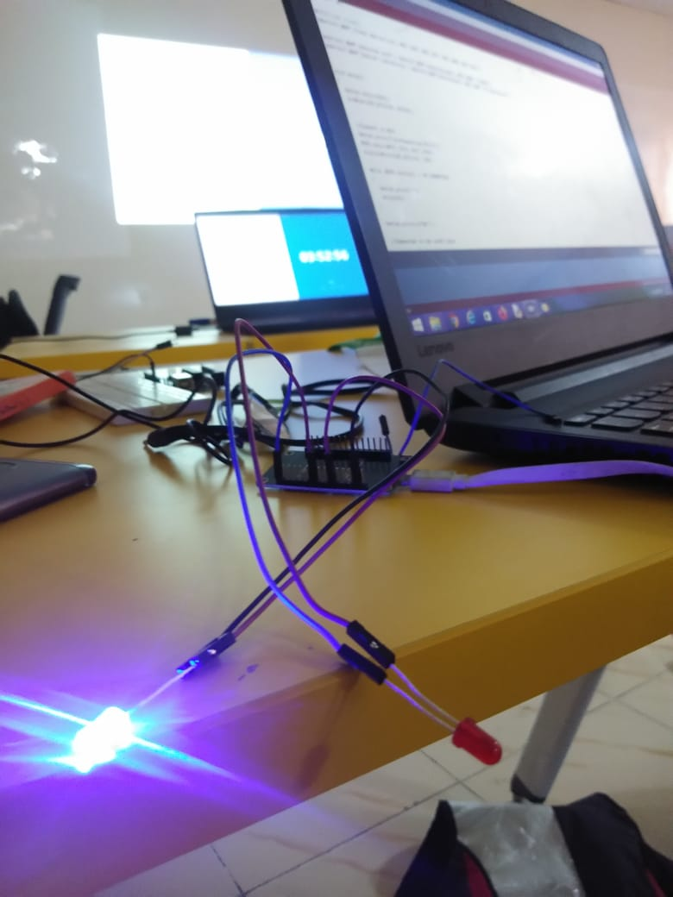

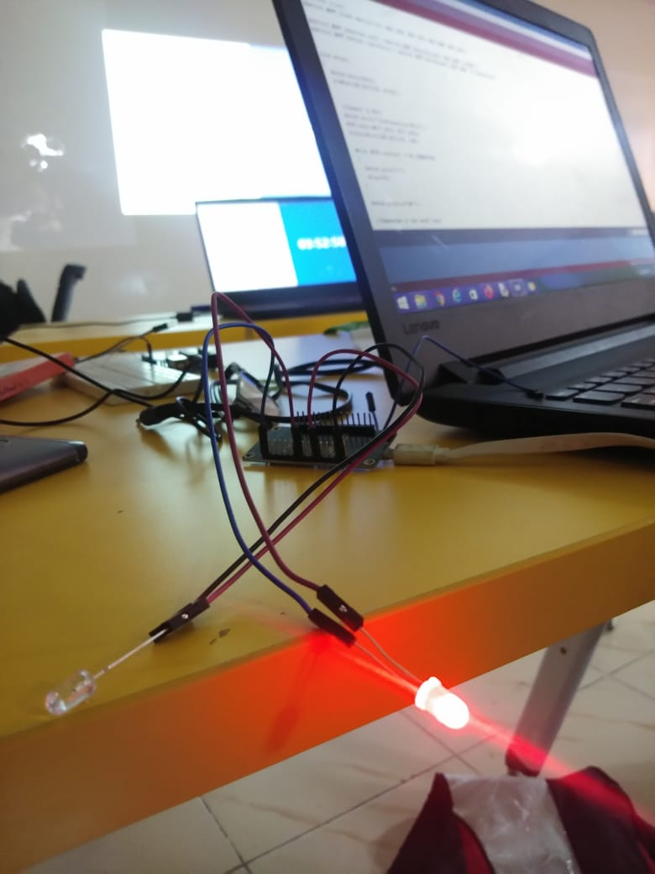

**Look-Up Table :**

|  |  |
| --- | --- |
| **Command** | **Task** |
| 1. Access *Camera* | It access the camera and give a clear picture of the surrounding |
| 1. Adjusting *Threshold Video* | It allows your car to see the edges better during fog, smog, rain, etc. and makes it smarter |
| 1. Adjusting *Threshold Image* | It gives you a gaussian image for analyzation |
| 1. *Motion* Detection | It helps your car to understand various motion within its surrounding and behave according to situation. |
| 1. *Lane Line* Detection | It is important to be on your lane to follow rules and reduce accident risk. |
| 1. *Forward* | Moves Forward |
| 1. *Backward* | Moves Backward |
| 1. *Left* | Moves Left |
| 1. *Right* | Moves Right |

*Note:- Any word not in table will return* ***“Sorry”***

Access Camera

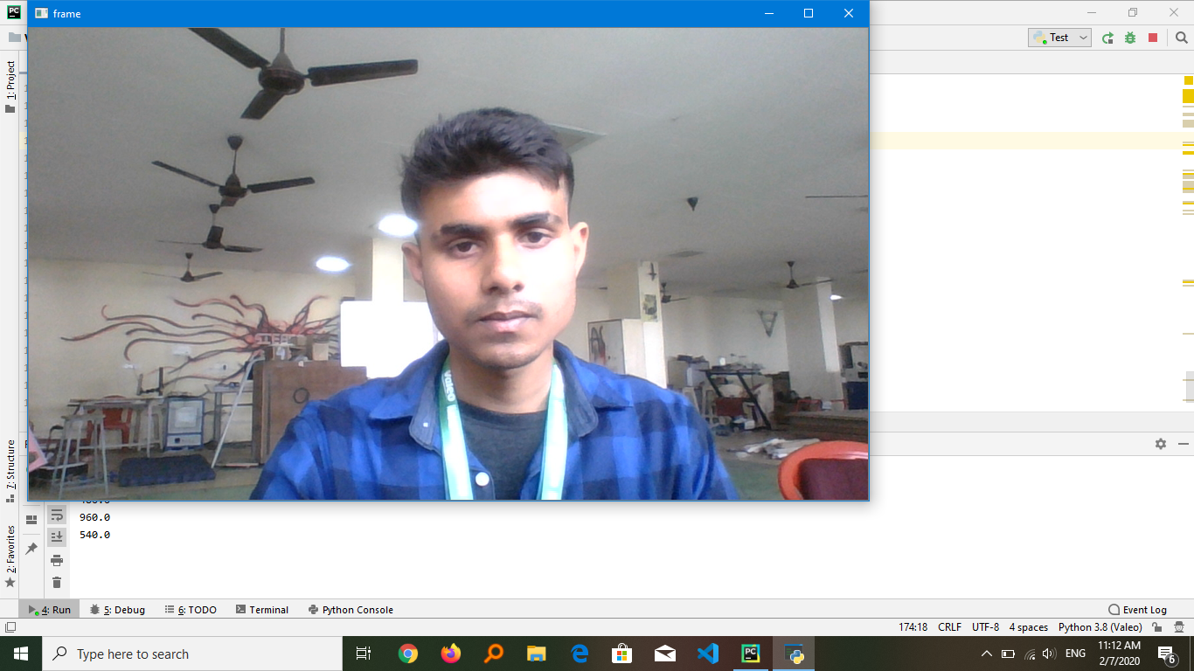

Adjusting Thresold Video(fog)

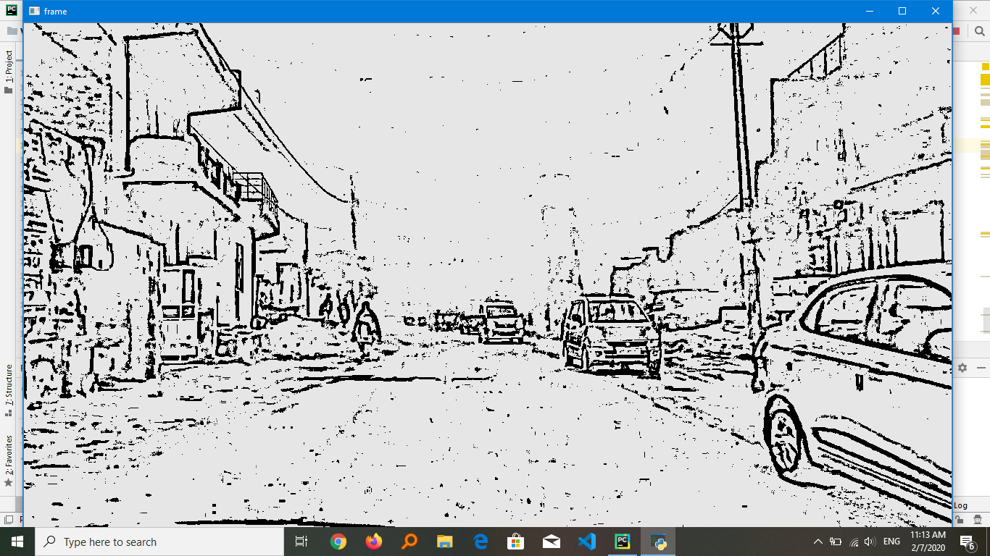

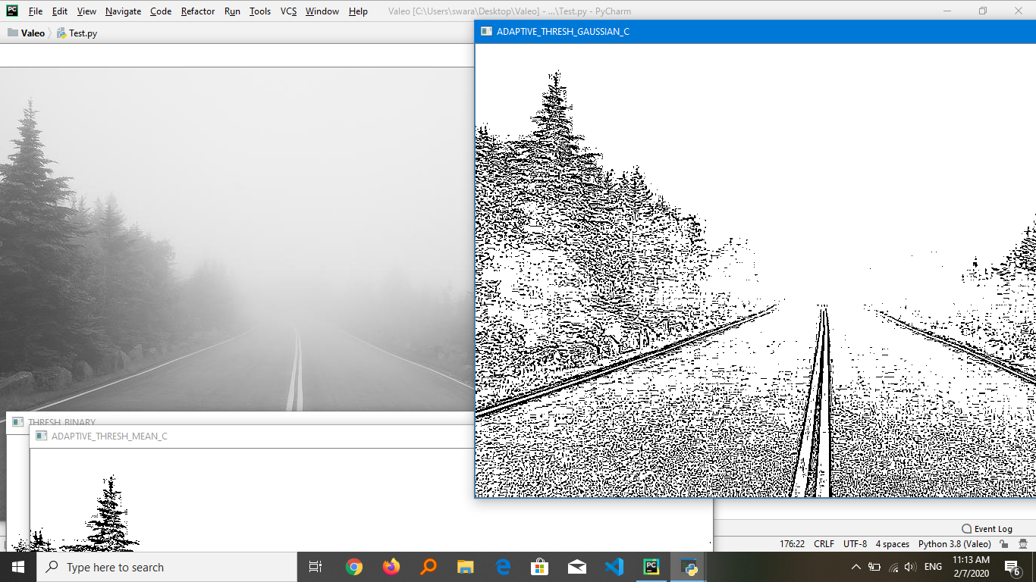

Lane Line Detection :

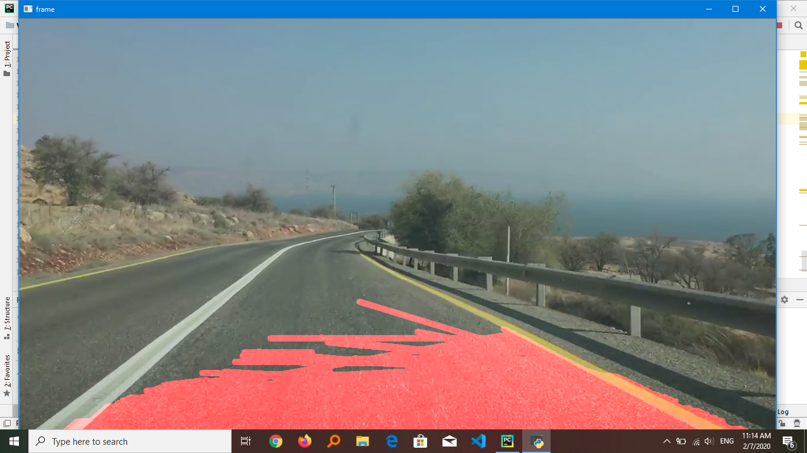

Motion Detection:

